# Data-driven alerts in Tableau

 This feature enables Tableau Server users to receive email when a mark crosses a visual threshold. Users can self-serve to create their own alerts on dashboards or vizzes in just 3 steps:

1. Select the axis you want to alert on.
2. Click the **Alert** button in the toolbar.
3. Choose the trigger condition and when to send it.

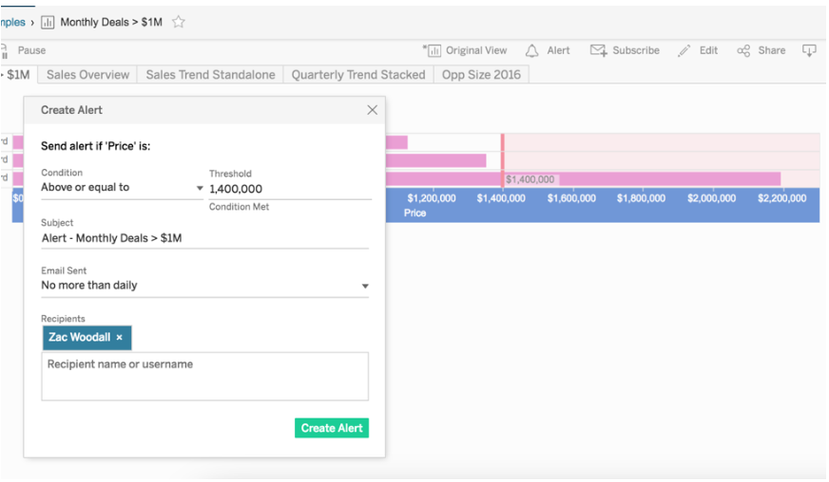

Alert owners can sign themselves and any other users up to receive alert emails in Tableau Server. Each recipient manages their own alert preferences with one click, directly from the email.

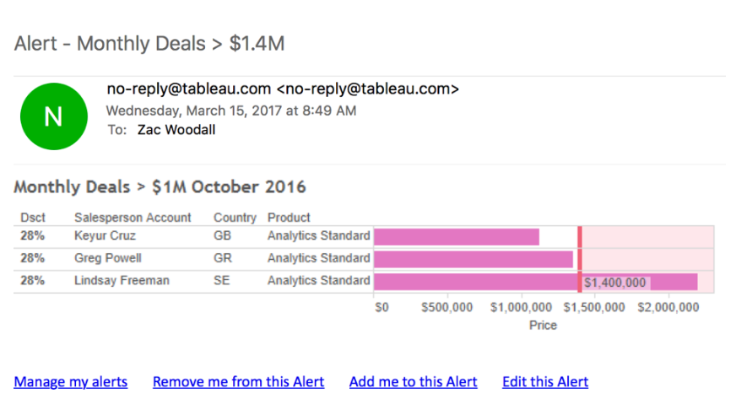

Managing alerts

Alerts you own or receive appear under **My Content** in Tableau Server, where you can customize your preferences.

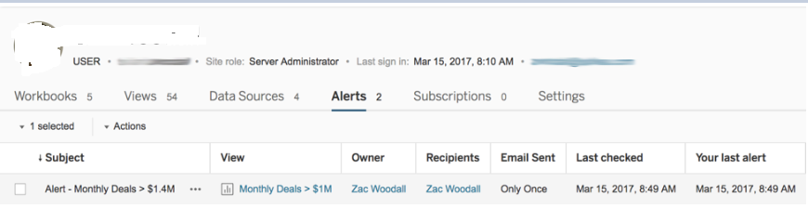

Site administrators can choose whether to enable or disable alerts for their site in **Site Settings**. As a site admin, you can view the list of all alerts created on a site, set the owner, edit, or delete the alert. With new administrative views, site admins can see which alerts are running on their server, how frequently, and if there are failures in the Backgrounder status for Non-Extract Tasks admin.

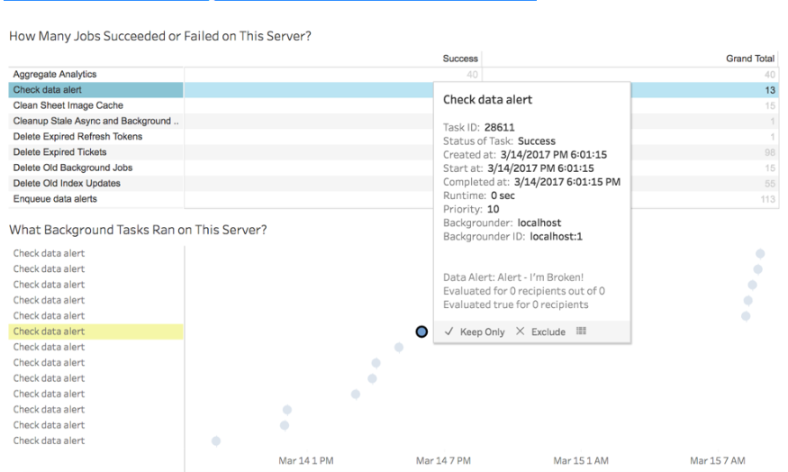

Server administrators control the frequency with which Tableau Server checks alerts. By default, this is set to 60 minutes. Server admins can set the check frequency through tabadmin:

tabadmin set dataAlerts.checkIntervalInMinutes   
tabadmin restart

Alerts are also checked automatically for extract-based views whenever any extract in the workbook is refreshed.